**Assignment -2**

PYTHON CODE

|  |  |
| --- | --- |
| Assignment Date | 01 October 2022 |
| Student Name | Mr. MOHAMMED SAJID . F |
| Student Roll Number | AC19UIT055 |
| Maximum Marks | 2 Marks |

**Question-1:**

Buid a python code, assume u get temperature and humidity values (generated with random function to a variable) and write a condition to continuously detect alarm in case of high temperature.

**CODE & OUTPUT:**

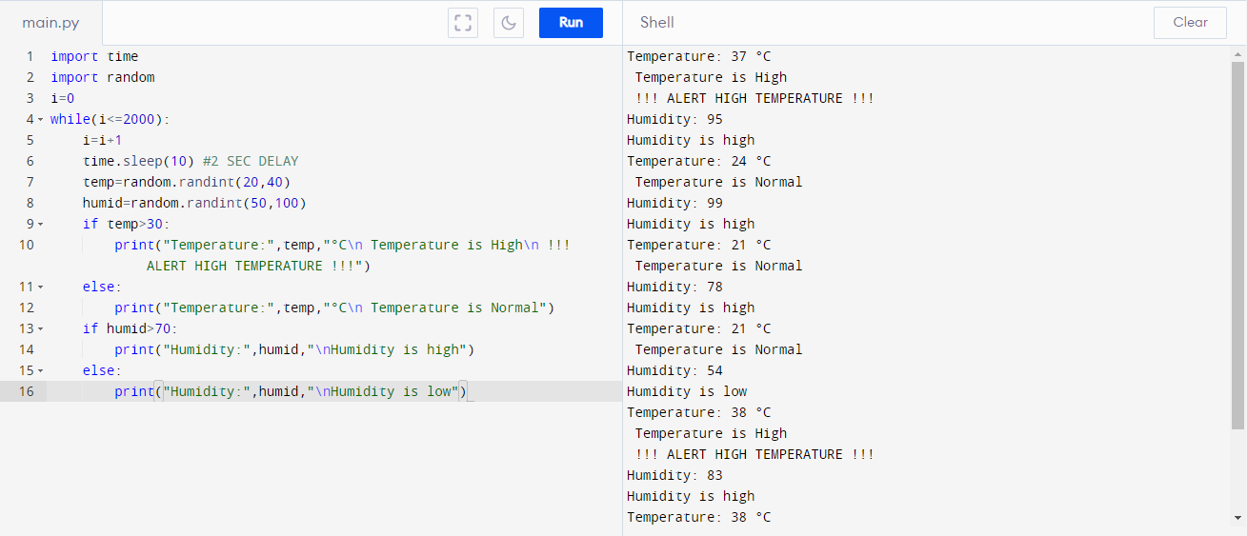

**CODE:**

import time

import random

i=0

while(i<=2000):

i=i+1

time.sleep(10) #2 SEC DELAY

temp=random.randint(20,40)

humid=random.randint(50,100)

if temp>30:

print("Temperature:",temp,"°C\n Temperature is High\n !!! ALERT HIGH TEMPERATURE !!!")

else:

print("Temperature:",temp,"°C\n Temperature is Normal")

if humid>70:

print("Humidity:",humid,"\nHumidity is high")

else:

print("Humidity:",humid,"\nHumidity is low")